**DIABLO MOUNTAIN RESEARCH CIRCUIT NOTES**

http://www.techlib.com/_themes/blueprnt/bluhorsa.gif

**Gas Tube Quench Circuit**

It seems to be common knowledge that a NE-2 or similar neon lamp can be pressed into service as radiation (x-ray) detector. But can a simple lamp serve as a low-level detector, possibly replacing a Geiger tube?  Initial experiments with a variable voltage source and a NE-2 in a relaxation circuit consisting of a series resistor and a small capacitor across the lamp showed no sensitivity to x-rays and moderate sensitivity to light. No attempt was made to use the lamp as an ion chamber or proportional detector but the volume is so tiny that success seems very unlikely. When uses as a "Geiger" detector, the lamp behaved erratically when in total darkness suggesting some sort of triggering mechanism but an x-ray source held near the tube did not change the behavior. It is possible that the high current pulse when the bulb triggers is responsible for some of the chaotic behavior.  In order to remove the effects of the high current spike when the lamp fires, the following quench circuit was constructed:

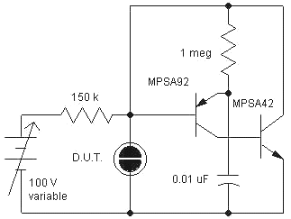

This circuit removes the potential across the ionized gas tube very quickly, keeping the current in the tube quite low and brief. When the tube fires, the base of the PNP drops below the emitter and the regenerative circuit turns on, rapidly reducing the voltage across the lamp to nearly zero. The total energy that makes it into the lamp is far lower than with a relaxation oscillator circuit. The 1 meg resistor and 0.01 uF capacitor determine the length of the reset pulse which is about 2 mS. A much shorter quench pulse is possible but for this experiment "dead time" is not important.

An NE-2 triggered at about 60 volts in room light, 62 volts in a darkened room, and at about 68 volts when painted black, wrapped with electrical tape, and placed in a box.  The lamp showed no sensitivity to a 4 mR/hour geiger counter test source in all cases. In one experiment, the voltage was increased until the circuit was resetting at a steady rate and there was no detectable change in the rate caused by bringing the radioactive source close to the lamp. If the NE-2 can detect x-rays at all, it isn't very sensitive and the bulb makes a far better light detector than geiger tube. It seems likely that the x-ray density needed to make a detectable difference would be quite high.

Interestingly, in oscillating mode, the resetting pulses could be made to synchronize to 60Hz by exposing the lamp to electric room lights.

Unlike a geiger tube, the bulb is designed to facilitate ionization so thermal emissions and electron/photon emissions may be too great to let the voltage reach a point where single particles can trigger a discharge. There may be (probably, in fact) radioactive gas added to the tube to facilitate starting and this source would mask other radiation. After all, it doesn't have to pass through the glass.

An OA2 voltage regulator tube was tried with similar results except that the triggering voltage was near 145 volts. At no point in any of the experiments was a sensitivity to the radioactive source seen. It is probably a good idea to stick with commercial geiger tubes and ion chambers. The larger gas tubes might be interesting as proportional detectors but I suspect the effort would be futile.

New Information: I've opened a few small neon lamps and found that the electrodes are indeed radioactive! An occasional electrode is surprisingly radioactive, causing fairly rapid clicking from my geiger counter despite the electrode's small size. This internal radiation makes the little bulbs into well-radiated ion chambers that I found to be useful as [high-value resistors](http://www.techlib.com/science/ion.html#Neon as Resistor).

http://www.techlib.com/_themes/blueprnt/bluhorsa.gif

The above circuit could use a mechanism to cause a reset in the event a trigger is missed and the tube is ionized. The following (untried) circuit adds a zener and a couple of resistors to cause a free-running oscillation when the lamp is on.

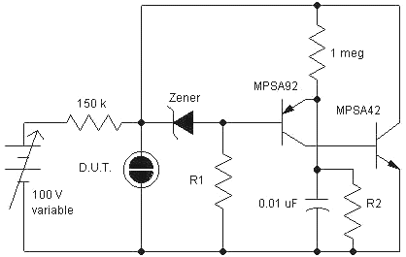

The emitter charges to a fraction of V determined by R2 and the base is a fixed amount below V due to the zener. If the neon is conducting, V is low and with the proper values for R2 and the zener voltage, the emitter voltage will be above the base causing a trigger. When the voltage is high, the base will be above the zener and the circuit will remain off.